Tutorial From: [Learn with Jon](https://www.youtube.com/@LearnWithJonVadar)

Project Name: Listing App

Language and Frameworks: Laravel, Inertia, Vue .JS – With Admin, User Roles and Profile, Filters, Dark Mode

Packages and Toils:

Laravel | Inertia JS | Vue JS | Tailwind CSS | Ziggy | Font Awesome | Mail Trap

Features: Authentication, Authorization, Emails, User Role, User Profile, CRUD Actions, File Upload, Dark Mode.

|  |  |
| --- | --- |
| **User Abilities** | **Admin Abilities** |
| * CRUD Actions * Update Profile | * Approve Listings * Suspend user accounts. * Delete user listings. * Update user’s role. |

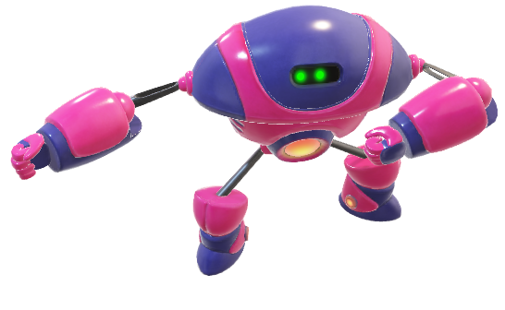

Let’s rock it!